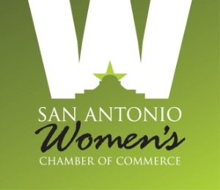

San Antonio Women’s Chamber of Commerce
Board of Director’s Meeting - March 4, 2019

IBC Bank – 8650 Fredericksburg Rd, SATX 78230
Lunch sponsored by IBC Bank

Agenda

- Welcome/Introductions Isenberg

- Pledge/Mission: All
Our Mission is to promote the business, economic and leadership development of women. While serving as a Board Member, I will demonstrate a passionate commitment to this Mission, the SAWCC stated goals, and the guiding principles that support them. Additionally, I will be a positive agent of change and affect the collective decisions of this governing body. Finally, I will be a thoughtful and positive architect as we build and support our organization.

- Report from Secretary Devlin
  - Approval of Minutes

- Report from Treasurer Leal
  - Quarterly Financials (Feb, May, Aug , Nov )

- Committee Reports
- Communications Wyatt/Villarreal/Hughes(staff report)
- Education/Leadership
  - Smart Women Series Polanco /Annunzio
  - Leadership Johnson / Docog
  - Bloomberg Becher / Helmy
- Events Taylor
  - Golf Taylor
  - Gala Blackwood
  - POWERhour! Luncheons Scharf-Zeldes
  - Mixers Gonzalez / Smolinksy
- Membership Gavallos / Sepulveda
- Com. Involvement/Board Orient. Neubert
- Charity of Choice Ciaravino
- Mentorship Program Dayle-Van Buskirk / Rattray

- Executive Director’s Report Katz

- Other Business

- Adjournment

