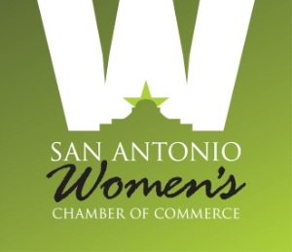

San Antonio Women’s Chamber of Commerce
IBC Bank – 8650 Fredericksburg Road, San Antonio, Texas 78230

September 9, 2019 - Agenda

- Welcome/Introductions Isenberg

- Pledge/Mission: All
Our Mission is to promote the business, economic and leadership development of women. While serving as a Board Member, I will demonstrate a passionate commitment to this Mission, the SAWCC stated goals, and the guiding principles that support them. Additionally, I will be a positive agent of change and affect the collective decisions of this governing body. Finally, I will be a thoughtful and positive architect as we build and support our organization.

- Report from Secretary Devlin
  - Approval of Minutes

- Report from Treasurer Leal
  - Quarterly Financials - Present 2nd Qtr. Financials

- Committee Reports
- Communications Wyatt/Villarreal/Hughes(staff report)
- Education/Leadership
  - Smart Women Series Polanco
  - Leadership Johnson / Docog
  - Bloomberg Becher / Helmy
- Events Taylor
  - Golf Taylor
  - POWERhour! Luncheons Scharf-Zeldes
  - Mixers Gonzalez / Smolinksy
- Membership Gavallos / Ayres / Cox
- Com. Involvement/Board Orient. Neubert
- Charity of Choice Ciaravino
- Mentorship Program Dayle-Van Buskirk / Rattray

- Exec. Dir’s. Report & SAWCCF Up-date Katz
- Gala – Blackwood
- Scholarship Program - Reece

- Other Business

- Adjournment

